Experiment-2.2

Aim of the Experiment : Human face detection using Haar features.

Problem Description :
RANSAC Algorithm:
RANSAC (Random Sample Consensus) is an iterative algorithm commonly used in computer vision and computer graphics to estimate parameters of a mathematical model from a set of observed data points that may contain outliers.
The main idea behind RANSAC is to repeatedly select a random subset of the data (sample), use this subset to fit a model, and then evaluate the quality of the model by counting how many data points are consistent with it. The subset of data points that agree well with the estimated model are called inliers, while the rest are considered outliers. The process is repeated for a predefined number of iterations, and the model with the largest number of inliers is typically selected as the best estimate.

Steps of RANSAC Algorithm:
- Initialization:
- Determine the minimum number of points required to estimate the transformation matrix. In this case, it's four points because an affine transformation requires four points.
- Set the maximum number of iterations for RANSAC.
- Iteration:
- Randomly select a subset of four matched points from the set of matched points.
- Estimate an affine transformation matrix using the selected subset of points.
- Calculate the transformation of all other points in one image using the estimated transformation matrix.
- Count the number of inliers, i.e., the number of points whose transformed position is close enough to their corresponding position in the other image.

- Model Evaluation:
- Repeat the iteration process for the specified number of iterations.
- Keep track of the transformation matrix that produced the highest number of inliers.
- Termination:
- After all iterations, select the transformation matrix with the highest number of inliers.
- Optionally, you can refine the selected transformation matrix using all inliers.

Code :
% Load the images
image1 = imread('Image1.png');
image2 = imread('Image2.png');

% Display the images
sgtitle("Ashish Kumar 23MAI10008")
subplot(2, 2, 1);
imshow(image1);
title('Image 1');
subplot(2, 2, 2);
imshow(image2);
title('Image 2');

% Convert images to grayscale
grayImage1 = rgb2gray(image1);
grayImage2 = rgb2gray(image2);

% Detect and extract features from the images
points1 = detectSURFFeatures(grayImage1);
points2 = detectSURFFeatures(grayImage2);
[features1, validPoints1] = extractFeatures(grayImage1, points1);
[features2, validPoints2] = extractFeatures(grayImage2, points2);

% Match features between the images
indexPairs = matchFeatures(features1, features2);

% Retrieve the locations of the matched points
matchedPoints1 = validPoints1(indexPairs(:, 1), :);
matchedPoints2 = validPoints2(indexPairs(:, 2), :);

% Visualize the matched points
subplot(2, 2, 3);
showMatchedFeatures(image1, image2, matchedPoints1, matchedPoints2, 'montage');
title('Matching Points');

% Check if there are enough matches to continue
if size(indexPairs, 1) < 4
title('No Matching Points');
disp('Not enough matches found for stitching!!');
else
% Use RANSAC to estimate the transformation matrix
[tform, inlierPoints1, inlierPoints2] = estimateGeometricTransform(matchedPoints1, matchedPoints2, 'affine');

% Use the transformation matrix to stitch the images
outputView = imref2d(size(grayImage1));
panorama = imwarp(image1, tform, 'OutputView', outputView);
% Blend the images together
panorama = imfuse(panorama, image2, 'blend', 'Scaling','joint');

% Display the stitched image
subplot(2, 2, 4);
imshow(panorama);
title('Stitched Image');
end

Output :
A) Matching Images:
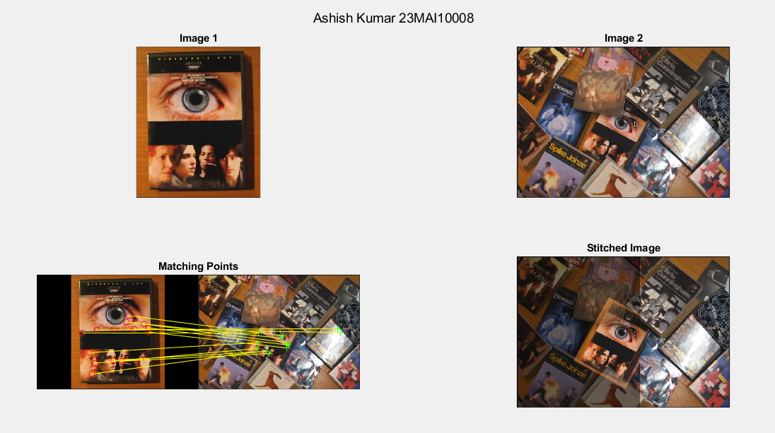

B) Non-Matching Images:
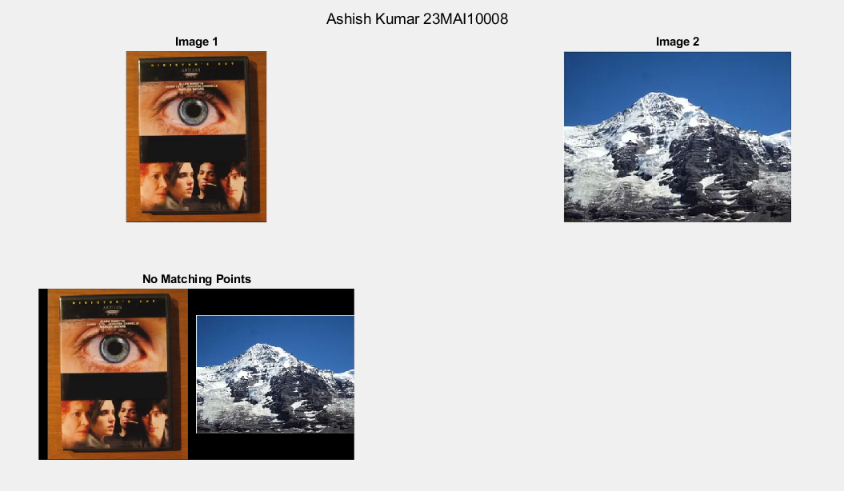

Learning outcomes :
- Learnt about the concept of RANSAC Algorithm.
- Learnt about how to match two images using RANSAC.
- Learnt about the Affine Transformation used for RANSAC.
- Learnt about the working of inliers in RANSAC Algorithm.
- Learnt about how to match features in two images.

